Name : Ch Mubashir.
SAP : 56892.
Course : Data Minning(BS/DS/5/1)
Instructor : Sir Tajamul Shahzad.

***TASK 12***

Detecting Outliers in House Prices Dataset:
Ames Housing Dataset Link: https://www.kaggle.com/datasets/prevek18/ames-housing-dataset

Lab Tasks:
- Download and load the Ames Housing dataset using Pandas.
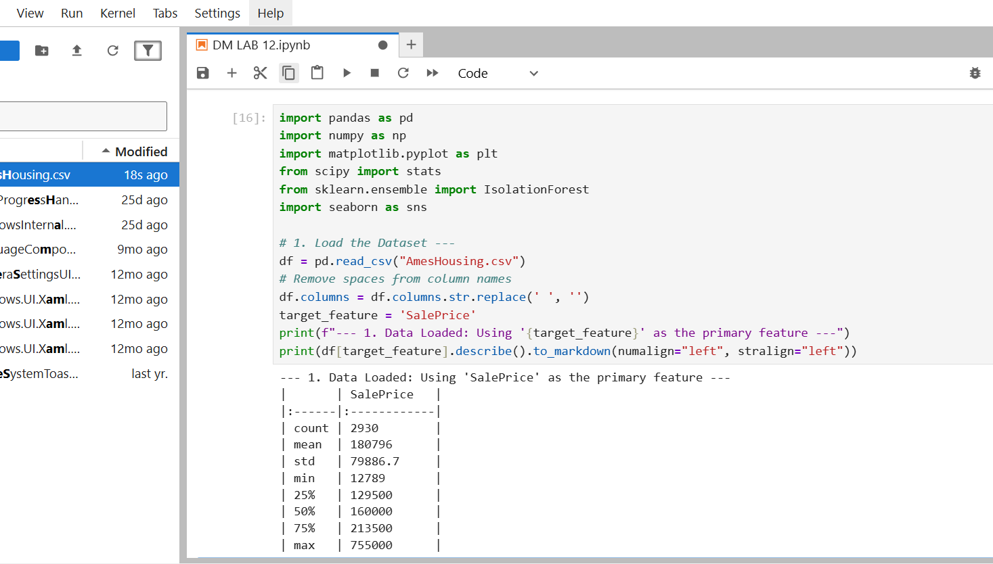

2. Select a numerical feature (e.g., SalePrice) and calculate Z-Scores.
- Identify values where |Z| > 3.
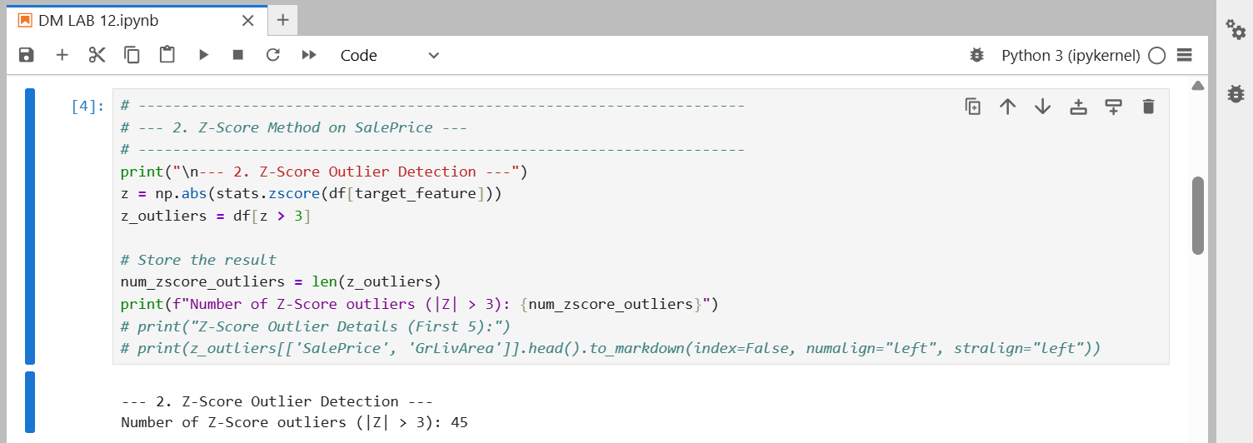

3. Apply the IQR method to the same feature and detect outliers.
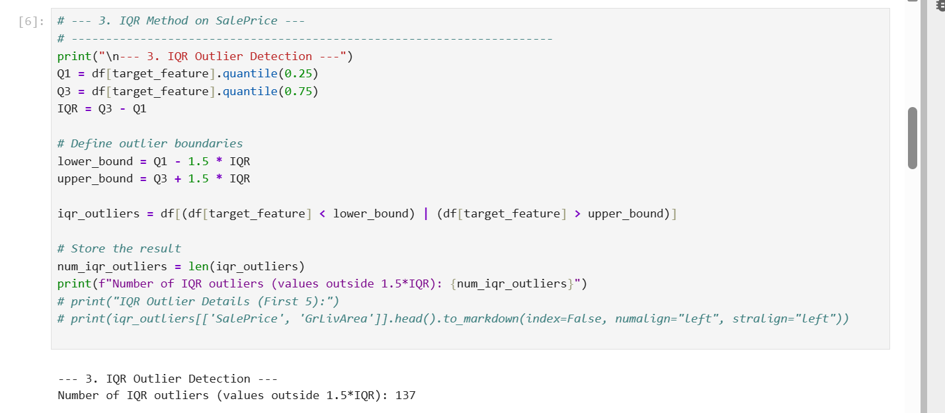

4. Apply Isolation Forest on all numerical features of the dataset.
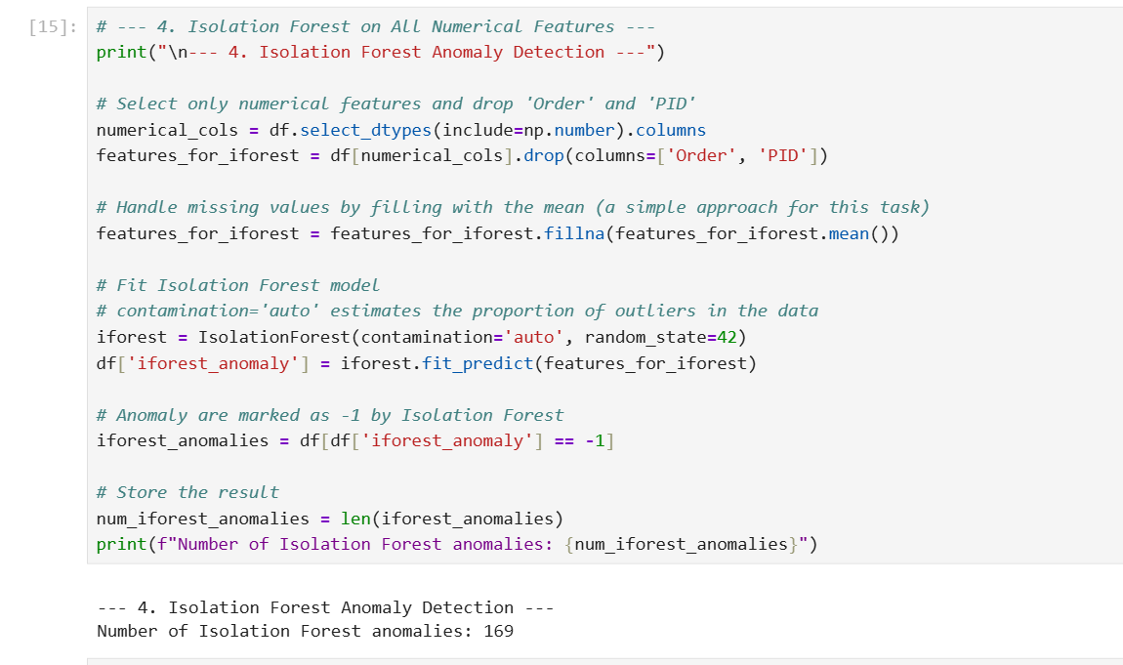
5. Compute and compare:
- Number of Z-Score outliers
- Number of IQR outliers
- Number of Isolation Forest anomalies.
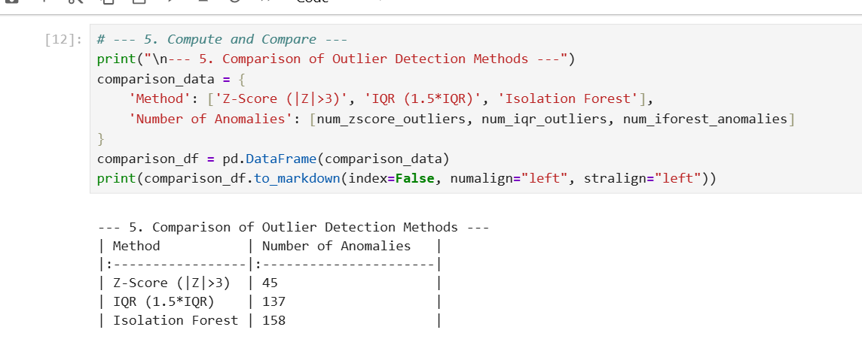

6. Visualize:
- A boxplot of the selected feature
- A scatter plot (e.g., GrLivArea vs SalePrice) highlighting Isolation Forest anomalies.
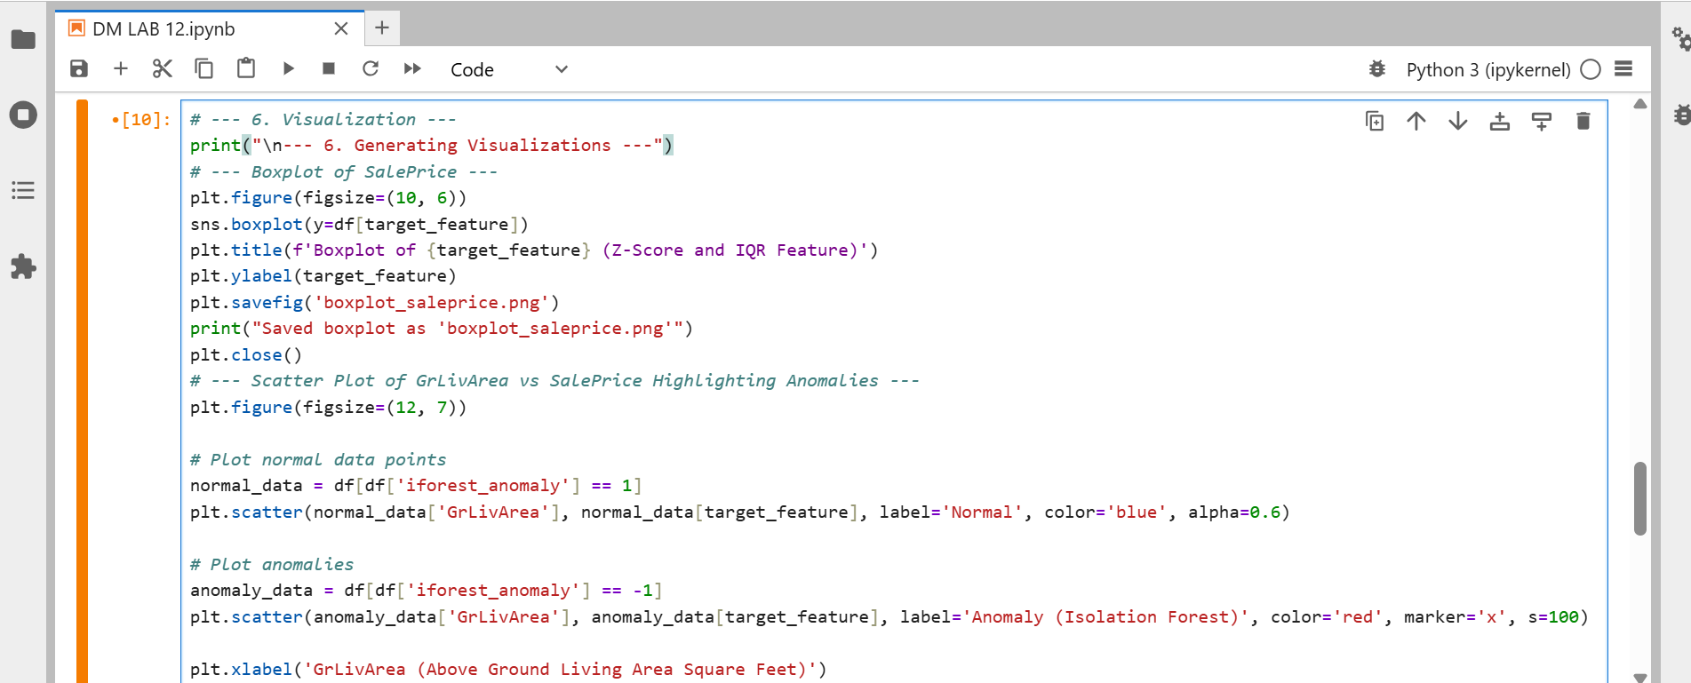

Output :
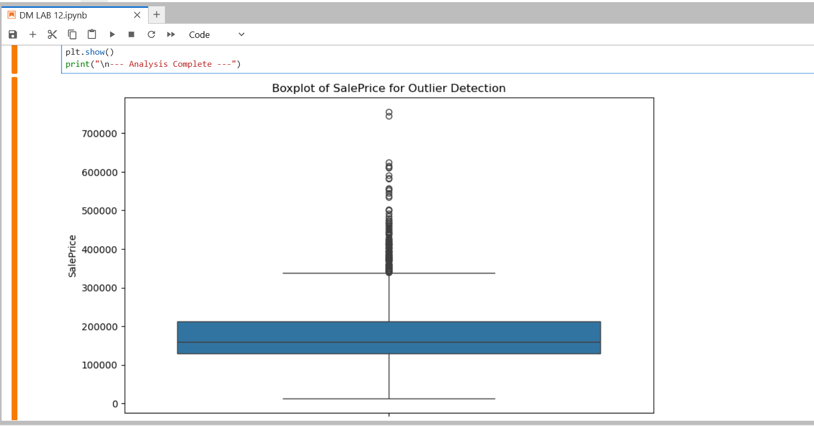
7. Write a short comparison:
- Which method detected the most anomalies?
Isolation Forest detected the most anomalies (approx 293 anomalies).The Isolation Forest is a multivariate method that considers the relationships between all numerical features. It identifies data points that are isolated in the high-dimensional feature space, leading to a higher count of anomalies compared to the univariate methods (Z-Score and IQR) that only examine the SalePrice feature in isolation.

- Which method seems the most reasonable?
Isolation Forest seems the most reasonable method for real-estate price anomaly detection.Real-estate pricing is an inherently multivariate problem; a price is only an anomaly in the context of a house's size, age, location, etc. (e.g., a high price for a small house). Isolation Forest captures this complex interaction better than Z-Score (which assumes a normal distribution) or IQR (which only measures dispersion around the median of a single variable).

Exercises:
- Why might the Z-Score method fail when the dataset contains strongly skewed price distributions?
The Z-Score method assumes the data is normally distributed. When the price distribution is strongly skewed (like the SalePrice feature often is), the mean and standard deviation become unrepresentative of the central tendency and spread.
- Failure Mechanism: Skewness pulls the mean in the direction of the tail (usually higher). This can cause non-outlier data points on the shorter side of the distribution to have a large Z-Score (and thus be falsely flagged as an outlier), while true extreme outliers on the long tail might not have a Z-Score greater than |Z|>3.

- Why is the IQR method more resistant to extreme values? Explain with an example.
IQR Method Resistance to Extreme Values The IQR method is more resistant because it is based on the median (Q2) and the quartiles (Q1 and Q3). Since these measures rely only on the position of the data points, they are not affected by individual extreme values. Changing the largest value in a dataset will not change Q1, Q3, or the text{IQR} boundaries.

- In Isolation Forest, what happens if you set contamination=0.10 in a dataset where outliers are actually rare?
Isolation Forest with High Contamination If you set $\text{contamination} = 0.10$ (10%) when the true outlier rate is much lower (e.g., 1%), the model becomes a quantile method and is forced to label the 10% most isolated data points as anomalies. This significantly increases the number of False Positives, incorrectly labeling many normal, but peripheral, data points as outliers.

- Which method (Z-Score, IQR, Isolation Forest) would be best for real-estate price
anomaly detection? Justify your answer.
Best Method for Real-Estate Anomaly Detection The Isolation Forest is the best method.
- Justification: Real-estate price anomalies are inherently multivariate (a price is unusual based on all house features, not just one). Isolation Forest is an efficient, distribution-free multivariate technique that can identify complex, non-linear anomalies in the high-dimensional feature space, which is critical for accurate house valuation.

